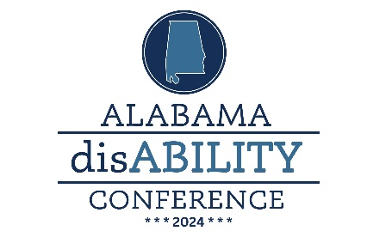

September 9-10,2024

Marriott Capital Hill

Prattville, AL

STATEWIDE AWARD NOMINATION FORM
Please check the Award Category for this Nomination:
 | Agency of Distinction |  |  |  | Exemplary Educator
 | Inclusive Employer |  |  |  | Distinguished Direct Support Professional (DSP)
 | Distinguished Professional of the Year |  |  |  | National Award for Distinguished Service
 | Distinguished Advocate of the Year |  |  |  | Employee of the year
 | Self-Advocate of Distinction |  |  |  | Promising Young Leader
 | Family of the Year Award |  |  |  | Legislative Advocate of the Year
 | Education Advocate of the Year |  |  |  | Rehabilitation Professional of the Year
 | ACE/Arc Arlene Ainsworth – “Executive Director of the Year” Award
Name of Nominee

Title or Position (if any):

Organization/Agency (if any):

Address:

City, State, Zip:

Phone: |  |  | Fax: |  |  |  | Email:
Using the descriptors for the award category, describe the activities of the nominee and tell why the nominee is deserving of this award. Describe characteristics of the nominee that make him/her/them worthy of recognition. Use additional sheets, as needed. Although not required, you may also submit relevant news clippings, letters of support, photographs, other documents or a synopsis of support for your nominee.
Name of Person Submitting Nomination:

Title/Position: |  |  |  |  |  | County:
Organization/Agency (if any):

Address:

City, State, Zip:

Phone: |  | Email:
DEADLINE FOR NOMINATIONS IS May 30, 2024 – EMAIL, FAX OR MAIL NOMINATION FORM AND MATERIALS TO: Alabama disABILITY Conference, c/o The Arc of Dekalb County, 201 Grand Ave SW, Fort Payne, AL 35967
Email: ali.rogers.arc@gmail.com Fax: 256-979-1457

