Alabama disABILITY Conference

September 8-10, 2024

Marriott Capitol Hill

Prattville, AL

See the Able

Not the Lable

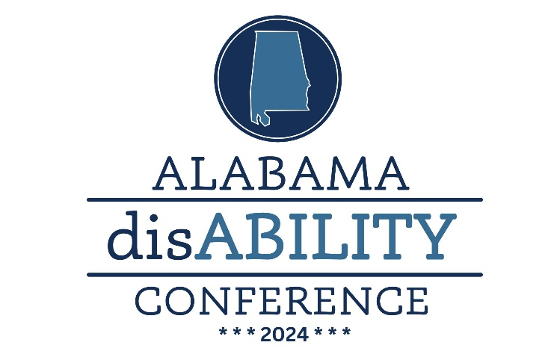

2024 Statewide Award Categories and Criteria

The deadline for nominations is May 31, 2024. Awards will be presented during the 2024 Alabama disAbility Conference September 8-10,2024. Nominee activities should have occurred during 2023.

Agency of Distinction – Honors a public or private community organization that provides exemplary support and demonstrates a commitment to community inclusion for people with disabilities.
Exemplary Educator – Honors an Alabama educator who has demonstrated excellence in providing for the education of students with developmental and other disabilities. Nominees for this award may include teachers/coaches, principals, local administrators, school board members, college faculty, etc.
Education Advocate of the Year – Recognizes a policy leader in education whose advocacy has had a significant statewide impact on the quality of life for people with I/DD. Recipients of the award may be policy leaders in primary, secondary, or higher education.
Inclusive Employer – Honors an Alabama employer with an exceptional record of providing inclusive community employment opportunities and accommodations for people with disabilities.
Distinguished Direct Support Professional (DSP) – This award recognizes a Direct Support Professional who ‘goes the extra mile’ in supporting people with disabilities in their community with special emphasis on the values in the DSP Code of Ethics for Direct Support Professionals (see criteria attached).
Distinguished Professional of the Year – This award recognizes a Qualified Developmental Disability Professional or Case Manager recognized for their exceptional ability to listen to the true needs of those they coordinate services for, plan appropriately for outcomes that achieve an individual’s desired quality of life as they define it and/or meets their needs for community inclusion, and can provide demonstrated examples of those achieved inclusive outcomes (be sure these are reflected in the nomination form).
National Award for Distinguished Service – Recognizes an individual whose contributions have had a statewide and nationwide impact on the lives of individuals with intellectual and developmental disabilities at the local, state, and national levels.

Legislative Advocate of the Year – Recognizes a legislator or legislative staff whose advocacy has had a significant impact on the quality of life for people with I/DD. Recipients of the award may be a Legislator or staff member.
Distinguished Advocate of the Year – Recognizes an individual whose advocacy has had a direct and significant impact on the quality of life for people with I/DD. Recipients of the award may be a Legislator, DHR Case manager, DMH Case Manager, Attorney, physician, City/County Leaders, Community member, etc.
Employee of the Year – Honors a Self-Advocate who has demonstrated commitment to employment, is recognized by his/her employer as an exemplar employee and is a role model for other Self-Advocates in the pursuit of community inclusive employment.
Rehabilitation Professional of the Year – Honors a Rehabilitation Professional who has demonstrated commitment to advancing employment options for people with disabilities. This professional should be a role model for other Rehabilitation Professionals in the pursuit of community inclusive employment.
Self-Advocate of Distinction – Honors an outstanding self-advocate who has demonstrated leadership and promotes self-determination by being actively engaged in activities such as legislative advocacy, activities of a Board of Directors or city council, a speaker in public speaking engagements, activities of a civic group that promotes inclusion, etc.
Promising Young Leader – Honors an individual or a group who has demonstrated outstanding leadership potential as seen in volunteer efforts on special projects or events that enhance opportunities for people with disabilities in their community. (Should not be nominated for Community Service)
Family of the Year Award – Recognizes a family having a member with intellectual and developmental disabilities who has been an inspiration to other families.
ACE/Arc Arlene Ainsworth – “Executive Director of the Year” Award -An Executive Director of a local chapter of The Arc or as the Executive Director of The Arc of Alabama. This individual must have made some contribution to ACE/Arc through membership, committee work and regular attendance at scheduled meetings. The award nominee must have demonstrated an active and viable role in advocacy, service, and agency administration to benefit persons with intellectual/developmental disabilities.

